# Library Management System Refresh

CISK 503

Summer 2017

Texas A&M University – Central Texas

A Team Consulting

Brian Combs

Juan Maldonado

Jon Seigle

Contents

Library Management System Refresh 1

A Team PROJECT DOCUMENTATION 3

1.1.1 OVERVIEW AND LIMITATIONS 3

1.1.2 PROPOSITION 3

1.2.1 DESCRIPTION 3

1.2.2 STAKEHOLDERS 4

1.2.3 MOV 4

1.2.4 PROJECT REQUIREMENTS AND FEATURES 4

1.2.5 PROJECT DELIVERABLES 5

1.2.6 PROJECT SCOPE 5

1.2.7 PROJECT SCHEDULE 6

1.2.8 PROPOSED PROJECT BUDGET 6

1.2.9 TERMINOLOGY 7

DESIGN 8

2.1 HIGH LEVEL SOFTWARE DESIGN 8

2.1.1 ARCHITECTURE 8

2.1.2 MySQL DATABASE 8

2.1.3 CLASS OBJECTS 8

2.1.4 USERS 9

2.1.5 DATAFLOW 9

2.1.6 SECURITY 10

2.2 DATABASE DESIGN OF THE SYSTEM 10

2.3 UNIFIED MODELING LANGUAGE OBJECT DESIGNS 11

# A Team PROJECT DOCUMENTATION

### 1.1.1 OVERVIEW AND LIMITATIONS

Our customer, TAMUCT Library has approached us to revamp and design a new library management system that will meet their needs. The customer relies on this database for managing book searches, reservations, and checkout functions for all patrons. The customer has expressed issues with the existing database being slow and non-scalable for their growing needs.

### 1.1.2 PROPOSITION

The new library management system will be a two-part upgrade. First of all, the application to interface with the database will be designed, created, and implemented. Secondly, the application will reference a back-end MySQL database for informational queries and storage of new information. The new management system will provide speed, accuracy, and scalability to the growing needs of the organization.

### 1.2.1 DESCRIPTION

This project covers the design and programming of a new library database system. The database is essential for day to day operations of the library. The growth of the organization over the past few years has stressed the existing database. The existing database and checkout system will be decommissioned and swapped out for a higher performing, more efficient application. Users will be able to manage the following aspects of the library:

* Catalog Management
* Patron Management
* Circulation

### 1.2.2 STAKEHOLDERS

The stakeholders are the patrons and administrators of the library database. All employees and staff will benefit from the upgrade. All library patrons, librarians, and administrators will directly benefit from increased, reliability, and speed of the checkout and search system.

### 1.2.3 MOV

Increase database query speed and efficiency. Increase uptime of availability of database for administrator and patron use. Hosted MySQL instance will bring database uptime to 99.92% availability. SLA will be maintained by Bluehost and any breaches of this SLA will result in a discount for monthly hosting charges.

### 1.2.4 PROJECT REQUIREMENTS AND FEATURES

Authors, ISBN’s, and Titles, must be searchable. There must be a way to see if the book is in stock or checked out. Once a book is checked out through the application, it should be updated in the database and be removed from the available books. There must be an administrator login for modifications to the database. The administrator’s login should allow the creation and deletion of entries to the checkout system.

The project requirements will be broken down into three main categories.

* The application design that is responsible for retrieving records and information from the database.
  + The application must interface with the database back end.
  + The programming should be secure in nature and avoid backdoors and security vulnerabilities.
* The database that houses the information and records.
  + The database should be normalized and have unique primary keys in each database
  + The database should have separate tables for different categories of information.
* The user interface that patrons, librarians, and administrators interface with when using the application.
  + The interface should be easy to read and utilize contrasting style, colors and fonts.
  + The interface must be ADA compliant.
  + The interface should be clearly labeled with labels on all interactive features.

### 1.2.5 PROJECT DELIVERABLES

* One application will be delivered to the library. This application will come as is, with a one week maintenance window for any last-minute issues or bug fixes. Upon the completion of the maintenance window, the final application will be delivered to the vendor and the transaction will be complete. There will not be any additional features added to the application at this time. This window will exist only for fixing existing issues or bugs. Any additional feature changes or requests will be a separate billable item to A Team Consulting.
* Finalized Risk Log
* Finalized Issue Log
* Project documentation

### 1.2.6 PROJECT SCOPE

A full refresh and upgrade of the existing database and checkout system will take place. The teams working together for this project will design and implement a robust scalable program, capable of increasing efficiency, reliability and maintainability of the resulting application.

### 1.2.7 PROJECT SCHEDULE

The project will take place over the course of 8 weeks. Planning will take place during the early part of the schedule. Development in the mid part of the schedule. Once development starts, testing will begin and bugs will be worked out. Once most of the bugs have been worked out, there will be a live deployment followed by a one week maintenance window to assist with any final issues.

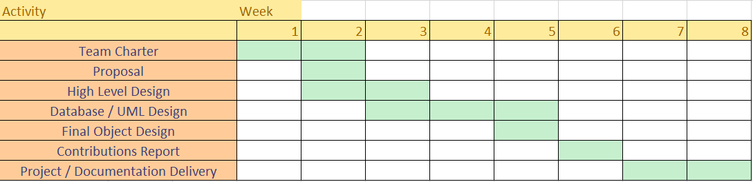

### 1.2.8 PROPOSED PROJECT BUDGET

Project management professional

$50 per hour

50 hours of work

Total PM cost: $2500

UI Design work

$50 per hour

25 hours of work

Total design cost: $1250

Program development / debugging

$75 per hour

100 hours of work

Total development cost: $7500

**GRAND TOTAL ESTIMATED COST: $11,250**

### 1.2.9 TERMINOLOGY

SCRUM – agile project management methodology for delivering products quickly

Site survey – analysis of existing environment

Trello board – Agile Project management tool for sprint work

GitHub repo – repository where changes to code are tracked and approved

SOW – statement of work

Database – software repository of stored permanent data

User interface – window in which users interact with the software application

ISBN – International Standard Book Number (unique book identifier)

Patron – library customer

UML diagram – unified modeling language diagram

IDE – Integrated development environment where code is written and tested

Language – computer programming language in which the application is written

HLD – High level design

HLDD – High level design document

## DESIGN

### 2.1 HIGH LEVEL SOFTWARE DESIGN

The library database/program will be designed in Visual Basic into a Windows Desktop Application. It will demonstrate best practices in coding and collaboration with the user of GitHub and version control. The program will be multi-featured with the ability for patrons, librarians, and administrators to use the same program. There will be no need for multiple versions of the program because features will be unlocked depending on account levels.

### 2.1.1 ARCHITECTURE

Windows Forms (WinForms) will be used to design the User Interface.

### 2.1.2 MySQL DATABASE

A MySQL Database will be provided during the class period to store the back-end application data on books and patrons.

### 2.1.3 CLASS OBJECTS

Class Objects will be used to provide functionality throughout the program.

There are six class objects that give functionality to the Library management system:

* Book.vb
* Hold.vb
* Patron.vb
* Patron_Librarian.vb
* Patron_Librarian_Administrator.vb
* Reservation.vb

There are two additional Database Objects that handle the MySQL database connection and the database exception functionalities.

* MySQLDatabaseConnvector.vb
* DatabaseException.vb

### 2.1.4 USERS

The application will have the ability to serve both users/patrons of the library, the librarians who work at the circulation desk, and the administrators of the library. All users regardless of role, will be able to use the same application to perform all required needs. Delivering one seamless application is beneficial in that it provides simplicity and ease of use to all users of the system.

### 2.1.5 DATAFLOW

The application will retrieve and store data in the MySQL instance. The MySQL instance is hosted through a service provider with redundant power and backup capabilities. The server is hosted through Bluehost Incorporated and the datacenter is physically located in Provo Utah.

All lookups / queries against the database will happen through the application. The application is the direct link to the database. Searching for books, checking for availability, placing holds, and checking out books will read and alter the database. Choosing to host the database with a third party hosting solution will provide the uptime and availability that the customer requires. Hosting the database also removes the responsibility of maintenance from the customer. The application is the only portion of the implemented system that will need maintenance. The upgrades to the database will be handled by the hosting provider as well.

### 2.1.6 SECURITY

Best practices for security will be used to ensure database integrity. The user account passwords will be hashed and stored securely in the database. The usernames and passwords will unlock certain functionality within the program depending on the type of account. Patrons will have different permissions from Librarians, and Librarians will have different permissions from administrators.

### 2.2 DATABASE DESIGN OF THE SYSTEM

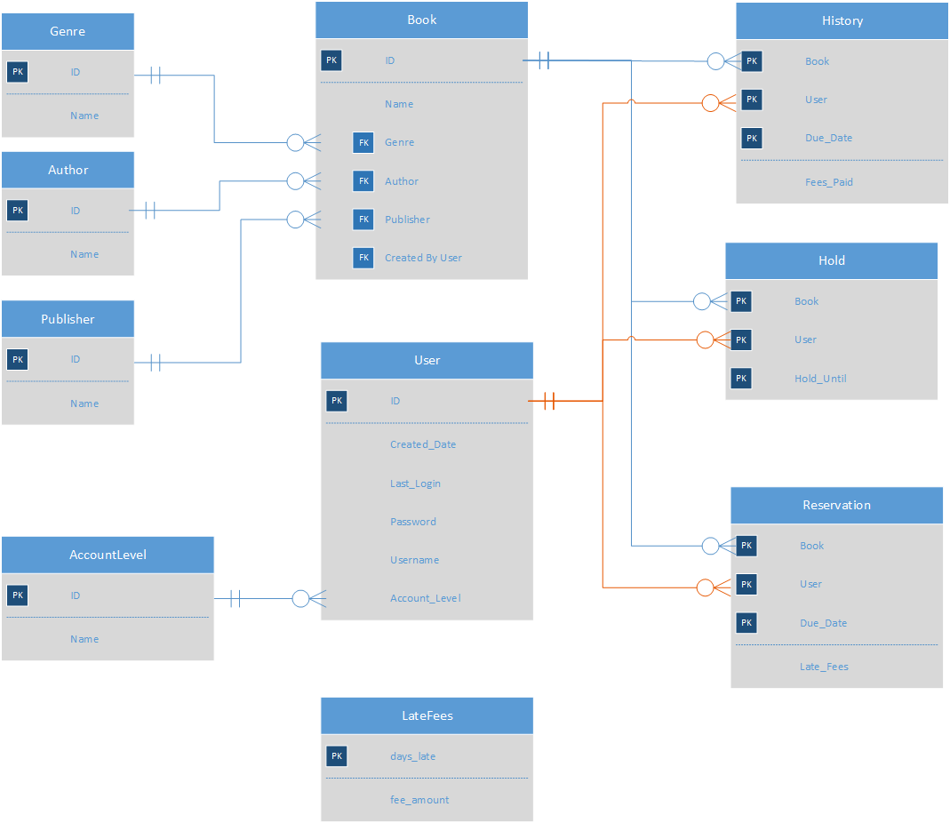

### 2.3 UNIFIED MODELING LANGUAGE OBJECT DESIGNS



### 2.4 Navigation

